# Programming Exam Sign-Up Form - How To

This Programming Exam Sign-Up google form was created to allow for online sign-ups for the cs240 Programming Exam Test.

This form has the following features:

* Students are allowed to sign up once, this is verified through their email
* Students can not change the time they signed up for
* Students will only see the exam time options that are not at full capacity
* TAs and professors may manually delete or edit a student’s submission
* TAs and professors may limit the number of submissions accepted for each time slot

## What are the parts?

### Documents

There are 2 main documents for this sign-up form. This documents can be accessed at the following link : [Programming Exam Sign-up Folder](https://drive.google.com/drive/folders/10tjyitPPPPEIfYC-kPLnKHkOoMOjqR46?usp=sharing)

* The **Programming Exam Sign-up (Responses)** document , this is a **google sheet** that stores all of the students’ responses
* The **Programming Exam Sign-up** document, this is a **google form** that the students use to submit an exam schedule request.

#### Programming Exam Sign-up (Responses) - google sheet

This google sheet contains 3 tabs which are explained below

##### Form Response 1 - Tab

*This tab is where the Google form stores its submissions.*

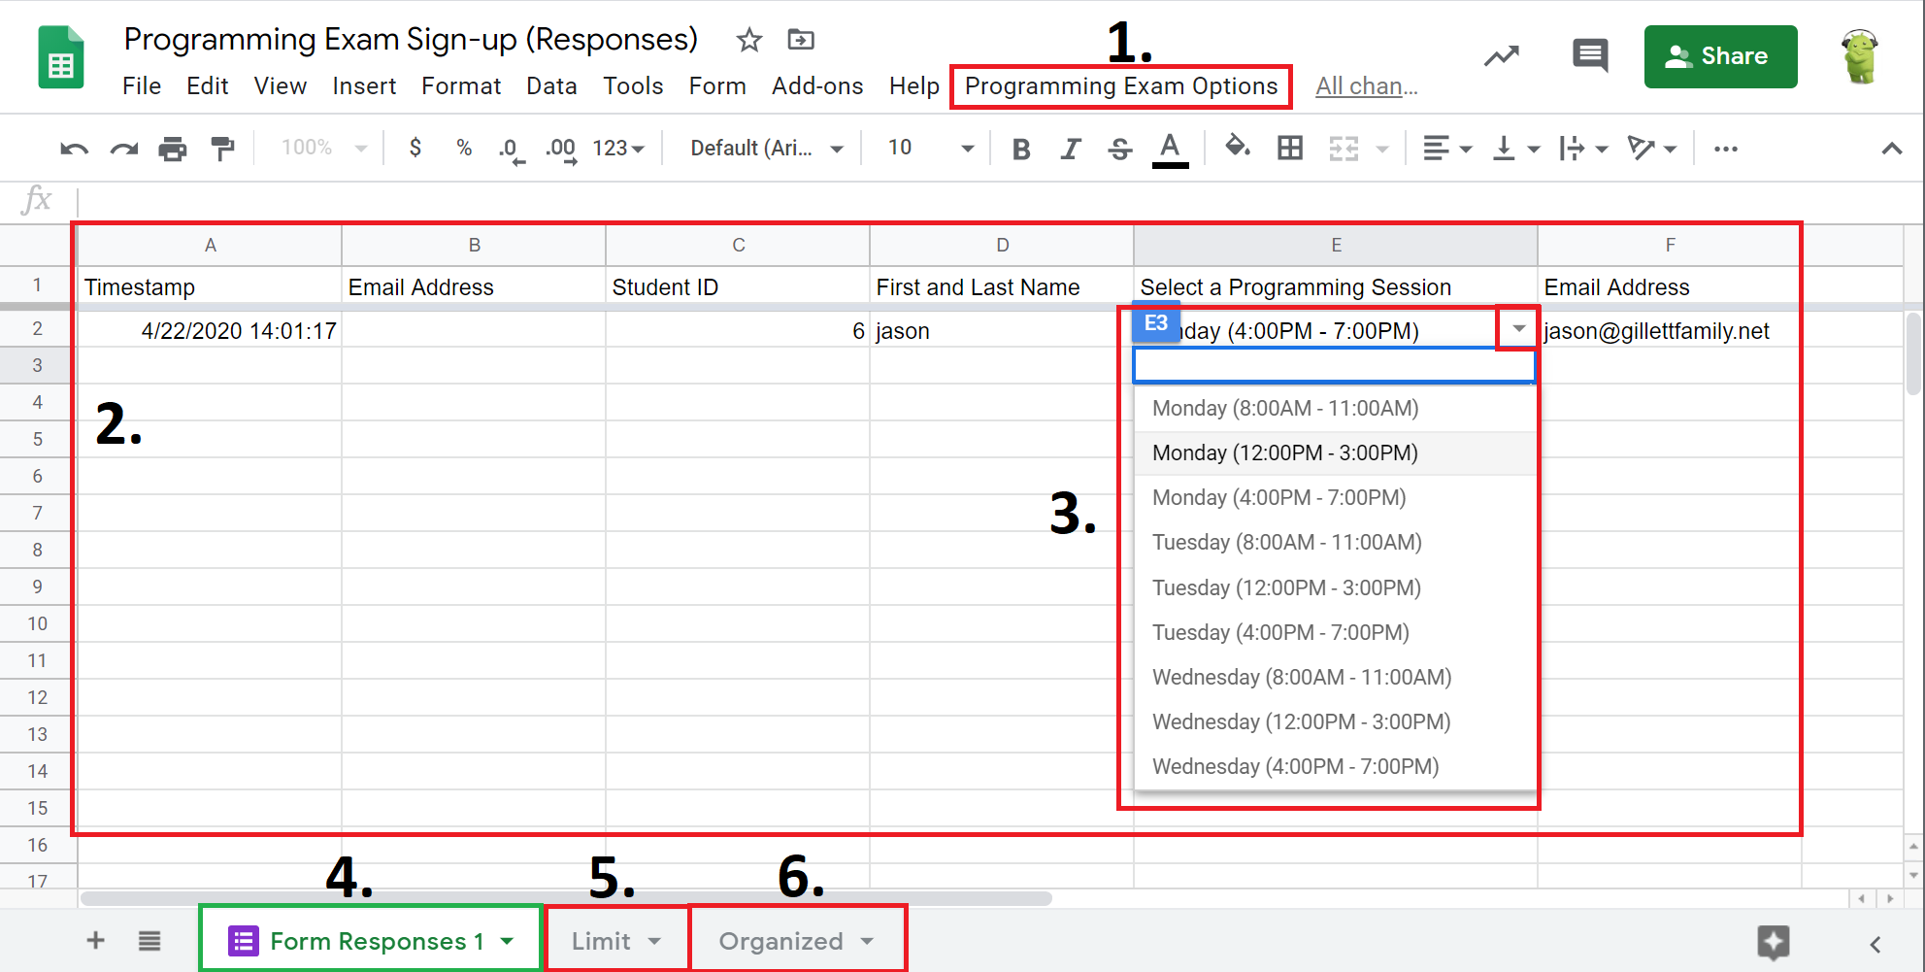

**Figure 1**. This is the special menu to manually update the google form and to add a new time slot option to the google form

**Figure 2.** This is where all of the data from the google form is stored

**Figure 3.** This is the drop down menu to make changing a students submission session easy.

**Figure 4.** This is the active tab (Form Response 1)

**Figure 5.** This tab will take you to the tab where the available time slots are managed

**Figure 6.** This tab will take you to the tab where the data in the (Form Response 1) is organized

##### Limit - Tab

*This is the tab that governs the time slot options on the google form. Using this page you can add or remove available time slots and manage the number of sign-ups allowed per time slot.*

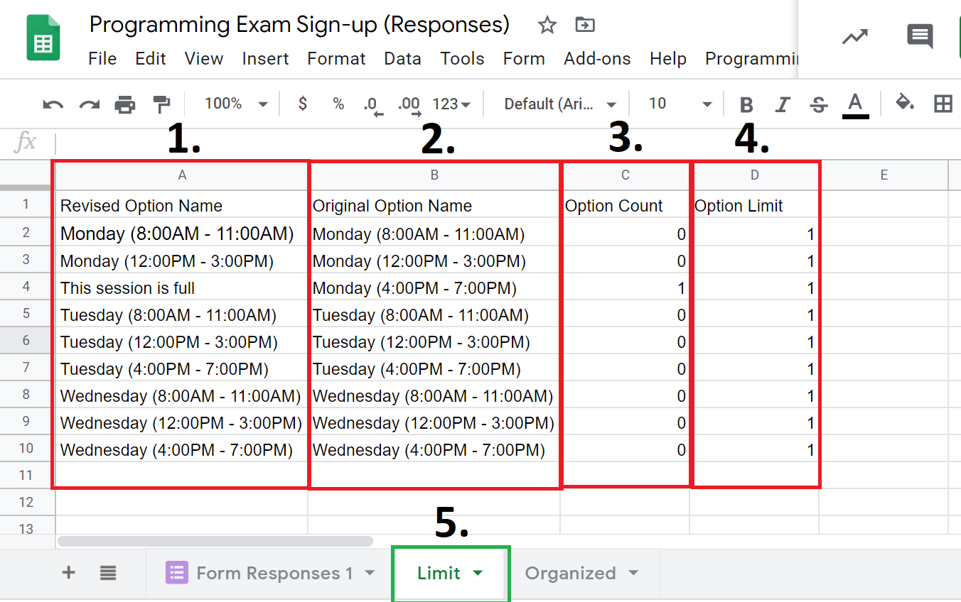

**Figure 1.** This column controls what is actually seen on the google sheets. If Option Count is equal to Option limit, then the cell in that row is changed to “This session is full”. This phrase is looked for in the SendEmailOnResponse google script and will trigger the time slot to be removed from the google form options.

**Figure 2.** This column controls what the cells in figure 1 are if Option Count < Option Limit

**Figure 3.** This column counts how many submissions of each time slot are in the “Form Responses 1” sheet.

**Figure 4.** This column controls how many students are able to sign up for each time slot

**Figure 5.** This is the active sheet tab

##### Organized - Tab

*This page displays the raw data form the “Form Responses 1” page by the submission date and the student’s name.*

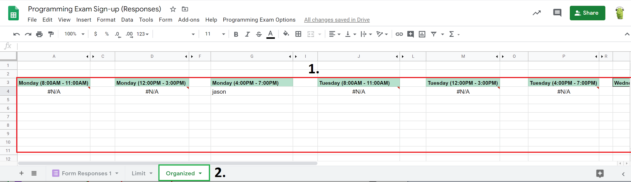

**Figure 1.** This is where the student’s information is shown, separated by the date and time of the programming session

**Figure 2.** This is the active sheet

### Scripts

There are 2 Google scripts that are used to implement this form, these scripts can be accessed at the following link: <https://script.google.com/> when signed into the CS240TA account

* The **SendEmailOnResponse** script, This script is linked to the Programming Exam Sign-up google form document
  + This script takes data from a students submission and compares it to data found on the Programming Exam google sheets document. Using this data, it verifies that the submission was valid and notifies the student.
* The **UpdateQuestions** Script, This script is linked to the Programming Exam Sign-up(Responses) google sheets document
  + This script is used to update the Programming Exam google form when a manual change is made to the student responses google sheet.
  + This script runs when the google sheet is opened to create the custom “Programming Exam Options” menu item
  + It runs when any edit is made to the google sheet

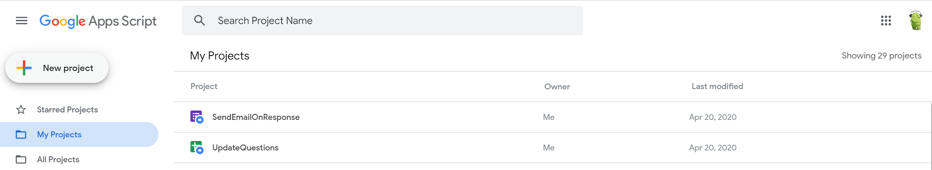

## FAQ

### **How do I share this google form with students**

1. Open the [Programming Exam Sign-up google form](https://drive.google.com/open?id=1T-mTuVlc4lHI9DLr6lf8O7hiZ--DL3eW7cpTVrTGdvw)
2. Click the “Send” button on the top right of the page
3. Copy and paste the share Link - <https://docs.google.com/forms/d/e/1FAIpQLSdY33-fQTiDdt59BIKQOkXSwtFL0Ag76Ld_p7ef-7JPD8m3mg/viewform?usp=sf_link>
4. Send out the Share link to students

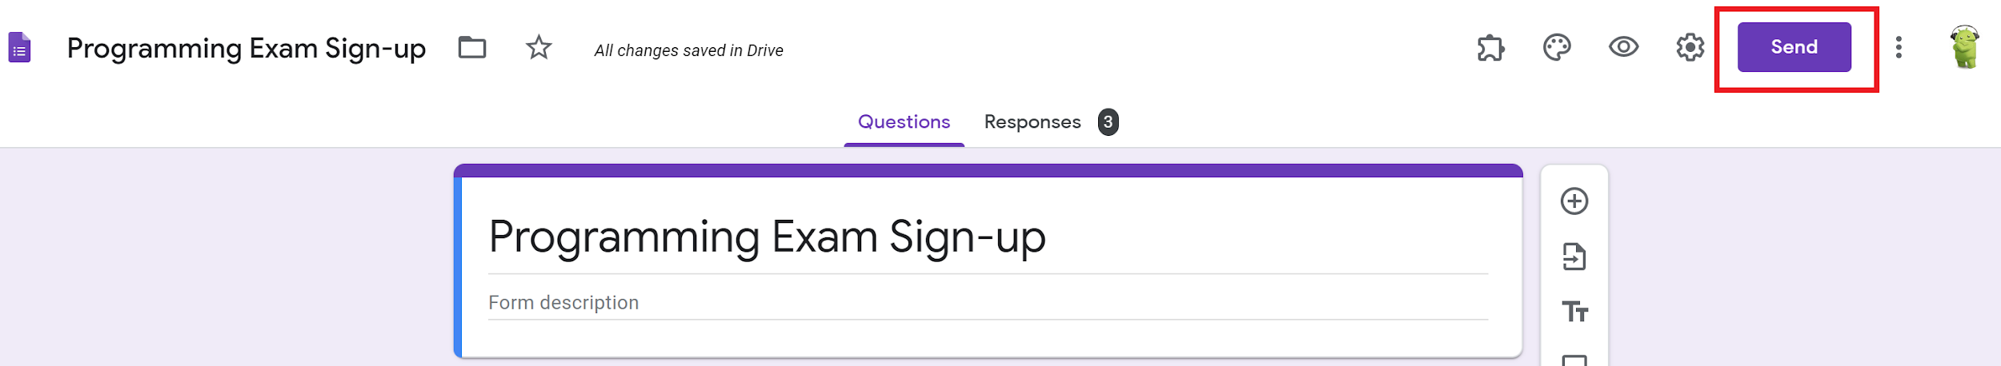

### **How do I view the students’ responses?**

Option 1 ( View the responses organized by date)

1. Open up the [Programming Exam Sign-up (Responses) sheet](https://docs.google.com/spreadsheets/d/1dHM9sU1RyQnsT-lxUUSnIHQHHw_HAqQ_nGR4iKBmdTE/edit?usp=sharing)
2. On the bottom of the document, click the Organized Tab
3. Student’s responses are organized by the programming session selected

Option 2 (View all of the responses in the order that they were received)

1. Open up the [Programming Exam Sign-up (Responses) sheet](https://docs.google.com/spreadsheets/d/1dHM9sU1RyQnsT-lxUUSnIHQHHw_HAqQ_nGR4iKBmdTE/edit?usp=sharing)
2. Navigate to the “Form Responses 1” tab.
3. All student responses will be found here.

### **How can a student change their exam time?**

Option 1: TA Deletes the response for the student

1. A student must email a CS240 Ta
2. The TA should delete the student’s old response
3. The TA should notify the student that they can resubmit the google form for a new time

Option 2: TA edits the response for the student

1. A student must email a CS240 Ta
2. The TA should find the students submission on the “Form Responses 1” tab
3. Using the drop down menu on the cell in the Programming session column, the TA should choose the new schedule time for the student

### **How do I remove a student’s entry?**

1. Open up the [Programming Exam Sign-up (Responses) sheet](https://docs.google.com/spreadsheets/d/1dHM9sU1RyQnsT-lxUUSnIHQHHw_HAqQ_nGR4iKBmdTE/edit?usp=sharing)
2. On the “Form Responses 1” page, CTRL-F search the students name
3. Right click anywhere in the row with the student’s information
4. Click, Delete Row.

### **How do I add a Time Slot for the Programming Exam?**

1. Open up the [Programming Exam Sign-up (Responses) sheet](https://docs.google.com/spreadsheets/d/1dHM9sU1RyQnsT-lxUUSnIHQHHw_HAqQ_nGR4iKBmdTE/edit?usp=sharing)

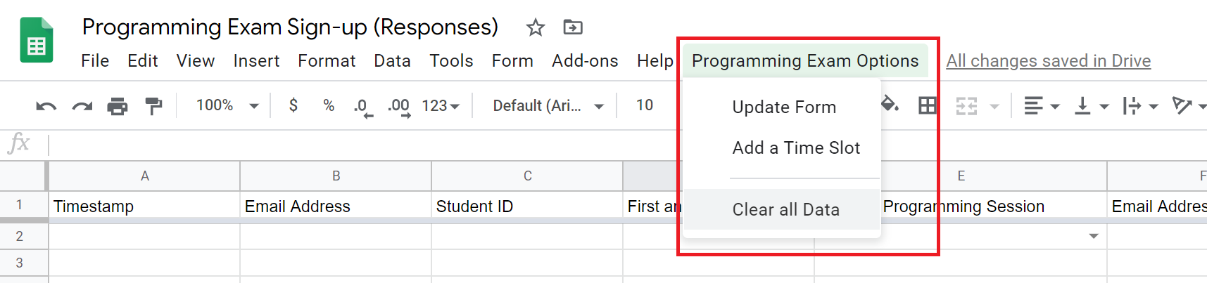

1. Click the “Programming Exam Options” menu item
2. Click “Add a Time Slot”

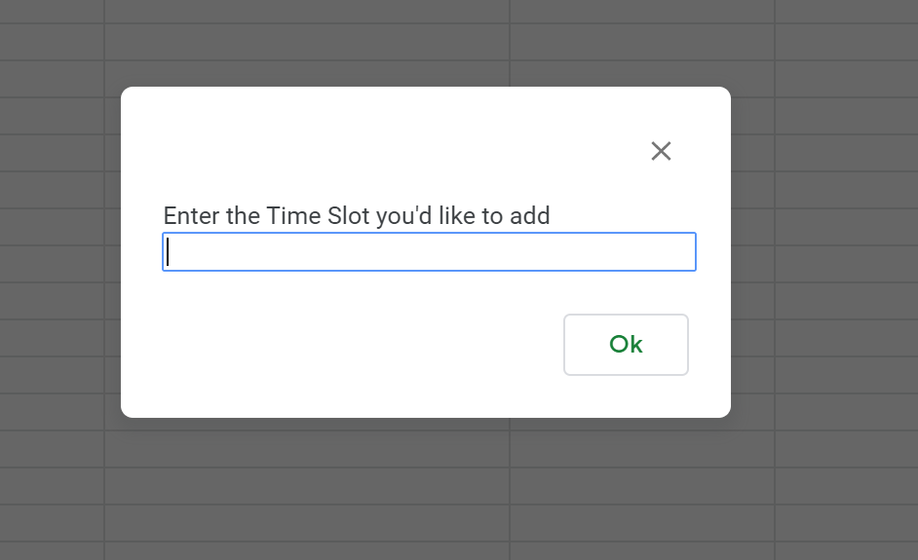

1. Type in the time slot you’d like to add, E.g. Thursday (12pm - 3pm)
2. Click ok
3. This time slot will be added to the google form, the “Limit” tabs, and a new column will be created for it on the “Organized” tab
4. By default the number of allowed students in this time slot will be 25 students

### **How to change how many students can register for each time slot?**

1. Open up the [Programming Exam Sign-up (Responses) shee](https://docs.google.com/spreadsheets/d/1dHM9sU1RyQnsT-lxUUSnIHQHHw_HAqQ_nGR4iKBmdTE/edit?usp=sharing)
2. Navigate to the “Limit” tab
3. Find the time slot you want to modify
4. Change the “Option Limit” value to the number of students you want in that time slot

### **How do I remove a time slot option?**

Option 1 (Set the limit to 0 to remove the option from the google form)

1. Open up the [Programming Exam Sign-up (Responses) sheet](https://docs.google.com/spreadsheets/d/1dHM9sU1RyQnsT-lxUUSnIHQHHw_HAqQ_nGR4iKBmdTE/edit?usp=sharing)
2. Navigate to the “Limit” tab
3. Find the time slot you want to remove
4. Set the option limit value to 0

Option 2 (Delete the time slot option from the form completely)

1. Open up the [Programming Exam Sign-up (Responses) sheet](https://docs.google.com/spreadsheets/d/1dHM9sU1RyQnsT-lxUUSnIHQHHw_HAqQ_nGR4iKBmdTE/edit?usp=sharing)
2. Navigate to the “Limit” tab
3. Find the time slot you want to remove
4. Right click the row of the time slot you want to remove
5. Click “delete row”
6. Navigate to the “Organized” tab
7. Find the time slot you want to remove

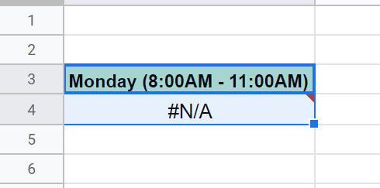

1. Highlight the first 2 cells of the time slot you want to remove
2. Press delete
   1. This will delete the title and the query string; removing the time slot entirely from the form.

### **How do I clear all responses from google form?**

1. Open up the [Programming Exam Sign-up (Responses) sheet](https://docs.google.com/spreadsheets/d/1dHM9sU1RyQnsT-lxUUSnIHQHHw_HAqQ_nGR4iKBmdTE/edit?usp=sharing)



1. Click the “Programming Exam Options” menu item
2. Click “Clear all Data”

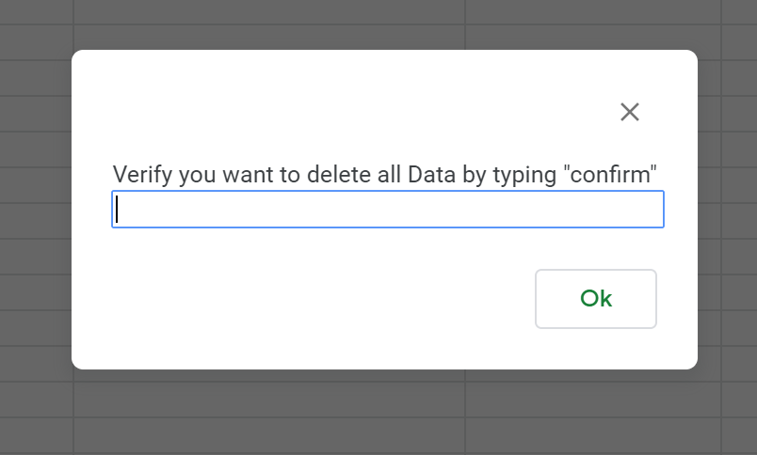

1. Type in :confirm
2. Click ok
3. All responses from the form and the spreadsheet will be cleared

### **What are the limitations of this form?**

* Students must verify that their submission was successful by checking their email
* Duplicate student submissions are checked only through email
  + Because of this students may submit the form twice by using two different emails
* Students who enter in an incorrect email that is still valid will not be able to receive the validation email.
  + This data will remain in the system and take up a position in a time slot until a TA removes the entry.
* Changing the Verification email that is sent out requires changing the actual google script code.
* This form hasn’t been tested with large amounts of concurrent signups,
  + It has been tested with 2-4 concurrent form submissions and works well.